Sponsorship Levels
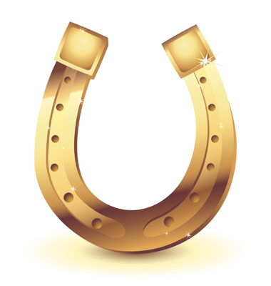 Platinum Horseshoe Sponsor $ 7,500.00
- Foursome
- Event Sponsor/Centerfold or another prominent spot in Event Program
- Endorsement at registration, in dinner hall, and post tournament display at Ray of Light farm. -Your Logo on our website, as well as your name listed as a sponsor in any printed promotions
- Four additional dinner tickets
Gold Horseshoe Sponsor $ 5,000.00
- Foursome
- Centerfold or another prominent spot in Event Program
- Endorsement at registration, in dinner hall, and post tournament display at Ray of Light farm. -Your Logo on our website, as well as your name listed as a sponsor in any printed promotions
- Four additional dinner tickets
Silver Horseshoe Sponsor $ 2,500.00
- Foursome
- Prominent listing in Event Program. Endorsement at registration and in dinner hall.
-Your Logo on our website, as well as your name listed as a sponsor in any printed promotions
-Two additional dinner tickets
Bronze Horseshoe Sponsor $ 1,500.00
-Foursome
-Prominent listing in event program. Endorsement at registration and in dinner hall
- One additional dinner ticket

Cart Sponsor $ 750.00
- Two golfers
-Listing in event program. Sign at bar
Cocktail Sponsor $ 750.00
- Two golfers
-Listing in event program. Sign at bar
Friend of Ray of Light $ 250.00
-Listing in event program/or Beer Sponsor
Tee Sponsor $ 100.00
-Tee sign

